 

| **FPT- APTECH COMPUTER EDUCATION** |
| --- |
| eProject Report |
| Computer Rental Store |
|  |
| | **Team V.I.P** | | | --- | --- | | **Group Member** | Pham Bao Ngoc - TH1901001 - Eproject_Code  Tran Thanh Hai - TH1907013 - Eproject_Code  Nguyen Huu Cong - TH1907015 - Eproject_Code  Vu Minh Duc - TH1904010 - Eproject_Code  Hoang Anh Son - D00757 - Eproject_Code | | **Batch** | <BatchName> | | **Center** | <Center code> | | **Semester** | 4 | |
|  |

| - Hanoi, 08/2021 - |
| --- |

**Contents**

1. Acknowledgements 4

2. Introduction 4

3. Problem Definition 4

3.1. Problem Abstraction 4

3.2. The Current System 4

3.3. The Proposed System 4

3.4. Boundaries of the System 4

3.5. Development Environment 4

4. Requirements and Business Flows 5

4.1. Customer Requirements 5

4.3. Use Case Diagram 6

5. Design 7

5.1. System Architecture 7

5.2. Class Diagram 7

5.3. Class Diagram Explanation 7

5.4. Sequence Diagram 7

5.7. Entity Relationship Diagram 7

5.8. Database Design 7

6. Management and Project Planning 10

6.1. Management Approach 10

6.2. Project Plan 10

6.3. Task Sheet and Task Sheet 10

7. Screenshots 11

8. Coding Convention 11

9. User Guide 12

Appendix 14

# **Acknowledgements**

# **Introduction**

# This document will present a detailed description of the website COMPUTER STORE - Computer rental and sale website.

Customers, managers (store owners), store employees will be the main targets for system users. This document will explain the system's goals and functions, the system's interfaces, functions, and operational problems.

This document is also intended for use by stakeholders and developers, as well as for customers to review prior to project implementation**.**

# **Problem Definition**

## ***Problem Abstraction***

Our India client is a company that owns a chain of mainframe rental stores in the center of the capital. They wanted a web that could help staff manage computers rent and sell pc parts, and make it easier for customers to access how to rent computers.

## ***The Current System***

Computer and Laptop rental stores have a large number of goods. Every day, there are hundreds of customers renting/returning machines. In addition, customers have the need to hire even after the end of the employee's shift.

Each day, 1 shift with a maximum of 8 hours, only one store employee undertakes all work related to renting/returning PCs and laptops. And all data is recorded on paper for management.

In addition, every time the store needs to see the statistics of the number of PCs and laptops to add new ones to the warehouse, it is almost impossible because the amount of management paperwork is too large.

## ***The Proposed System***

To solve the above problems, we want to build an online store system to serve the needs of using PCs and laptops efficiently and quickly. Make it easy for the store to support customers.

A website called Computer Store (temporarily called) builds solutions to use online stores, and the store's jobs are handled on the system.

The system provides statistics, reports and stores customer recommendations about the store.

## ***Boundaries of the System***

The system is used in the community for everyone who needs to rent a PC, Laptop. There are also store employees and shop owners to use.

## 

## 

## ***Development Environment***

Main language for programming our project: ASP.NET

Besides, we use a few platforms, web to manage and divide the work according to the group, such as:

* Github
* Trello
* Azure
* Postman
* Draw.io

Applications we use for programming and data management:

* Visual Studio
* Microsoft SQL Server Management
* GitHub Desktop
* Mockplus Classic
* StarUML

# **Requirements and Business Flows**

## ***Require about Function***

*The system includes functions to serve the operation of the chain of computer rental stores, below are the required functions of the system:*

1. *Join the system:*

* *Management will be created accounts to participate in the system, the login account will be created by the system administrator and give the necessary information to log in for employees.*

1. *Search information:*

* *Consultants and customers only need to search on the system to see if components and computers are available in the store to be able to place an order.*

1. *Buy products:*

* *We provide computer components including: RAM, CPU, VGA,... Customers can easily choose and pay in the cart.*

1. *Rent computer:*

* *When customers choose the computer they want to rent, they can enter their information and the type of computer and software they require. After the registration is complete, the profile has been approved and confirmed online, the technical staff can come to the house to install.*

1. *Check the rental - return of the computer:*

* *Customers can see which computers you have rented and the status of that computer rental (validity, overdue ...)*

1. *Statistics:*

* *The administrator will make statistics related to the purchase and sale of components and rental computers after each week.*

## ***Use Case Diagram***

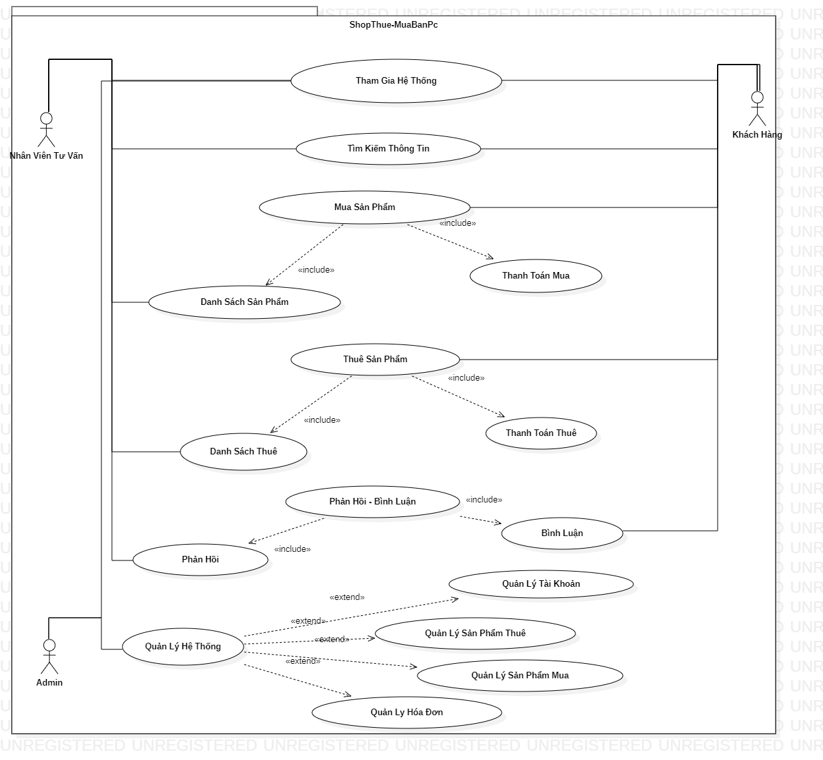

# **Design**

## ***System Architecture***

*The system includes 3 main user classes: customers, consultants, technical staff and managers.*

*In There, the customer logs in to the system, where information about that customer is stored, including: name, address, phone number, ... the customer can choose to order in the shopping cart and rent a computer in the rental basket. Complete the order when it is paid online. In addition, they have an additional section listing purchased and rented product information.*

*In addition, consultants and admin will be the ones responsible for making orders for customers, and managing that order according to the flow of the system.*

*After receiving the customer's order, the technical staff will deliver the machine and install it.*

## ***Class Diagram***

## 

## 

## 

## 

## 

## 

## ***Class Diagram Explanation***

*"User" is the general information to store basic information of the user class: Admin, Staffs , and Customers.*

*Besides, Admin, Customers, Staffs will have their own code to clearly distinguish the user class.*

*Customers and Staff have a few additional functions to change personal information and search for products themselves.*

*We divide it into 2 separate categories: buying products and renting computers:*

* *Rent computer including: order code, customer code, and basic customer information. In addition, the deposit and rental period are clearly listed to ensure transparency for customers.*
* *Buy products including :order code, customer code and basic customer information. The customer has added or removed products from the cart.*

## ***Entity Relationship Diagram***

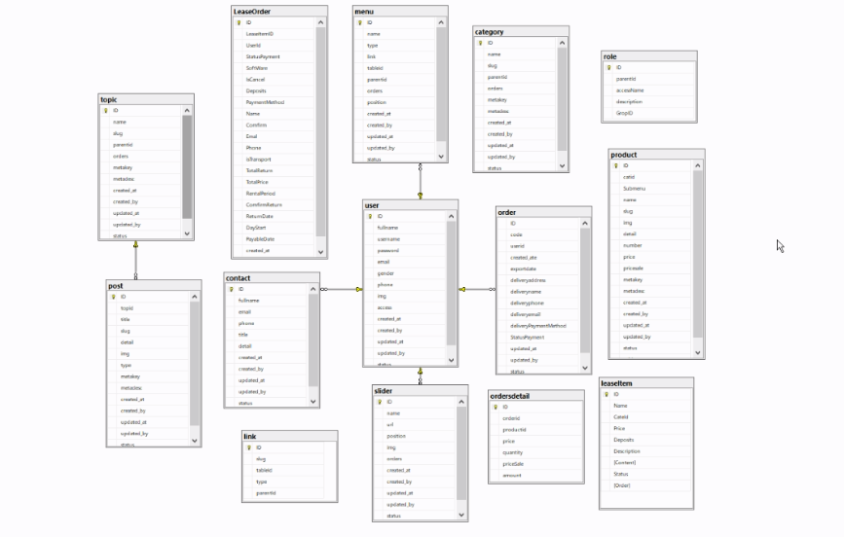

## 

## 

## 

## 

## 

## 

## 

## 

## 

## ***Database Design***

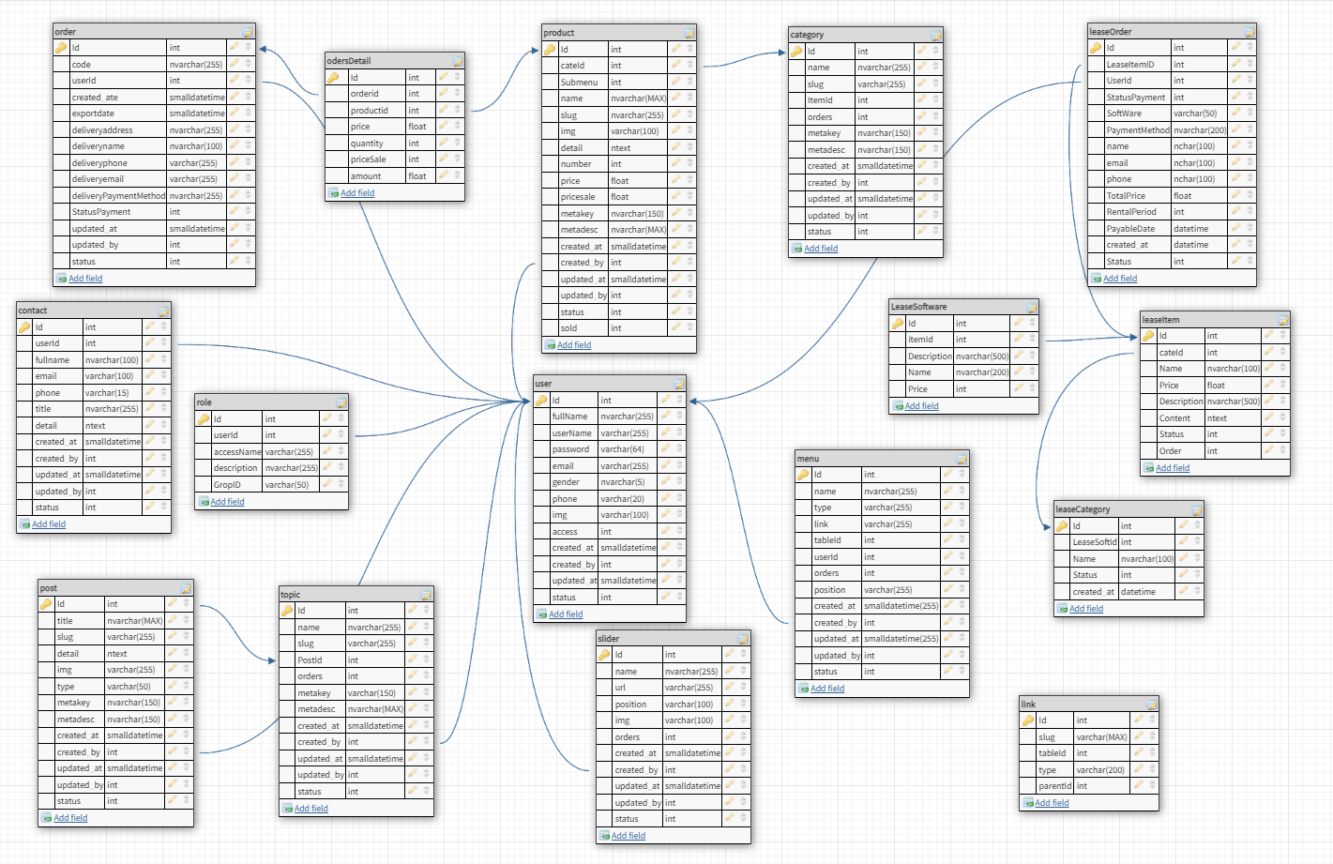

6. Management and Project Planning

## ***Management Approach***

*Team VIP has 5 members including 1 leader and 4 support members. The leader assigns clear and specific work to each member of the team, to easily manage and maximize the time to achieve the most effective work.*

## ***Project Plan and Task Sheet***



# **Screenshots**

1. *Home page*

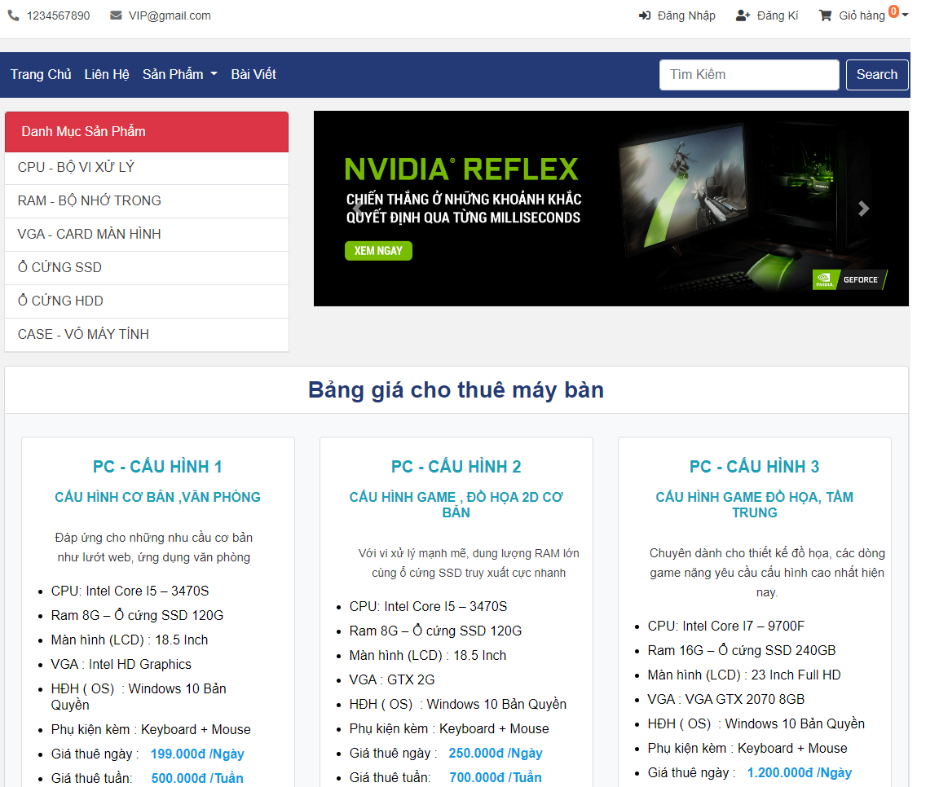

1. *Cart*

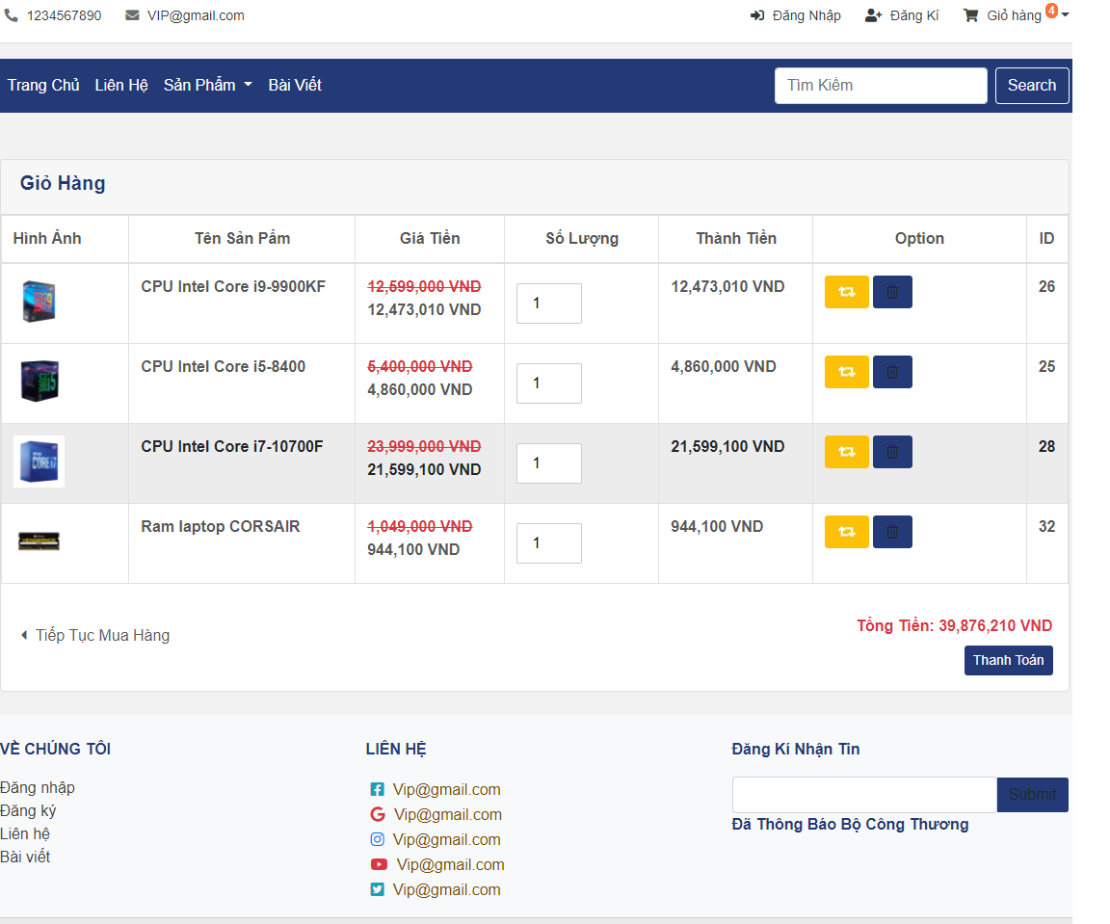

1. *Rent PC 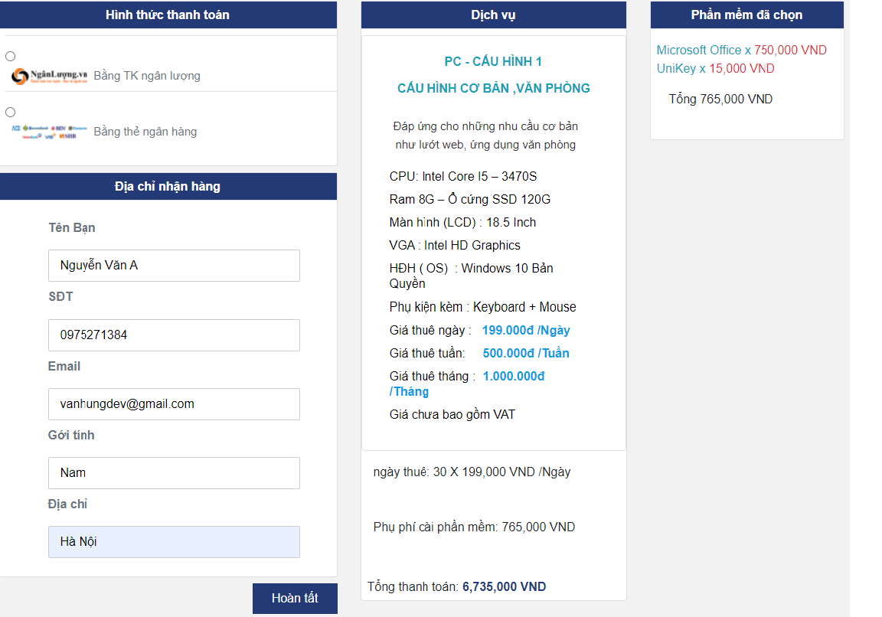*
2. *Admin*

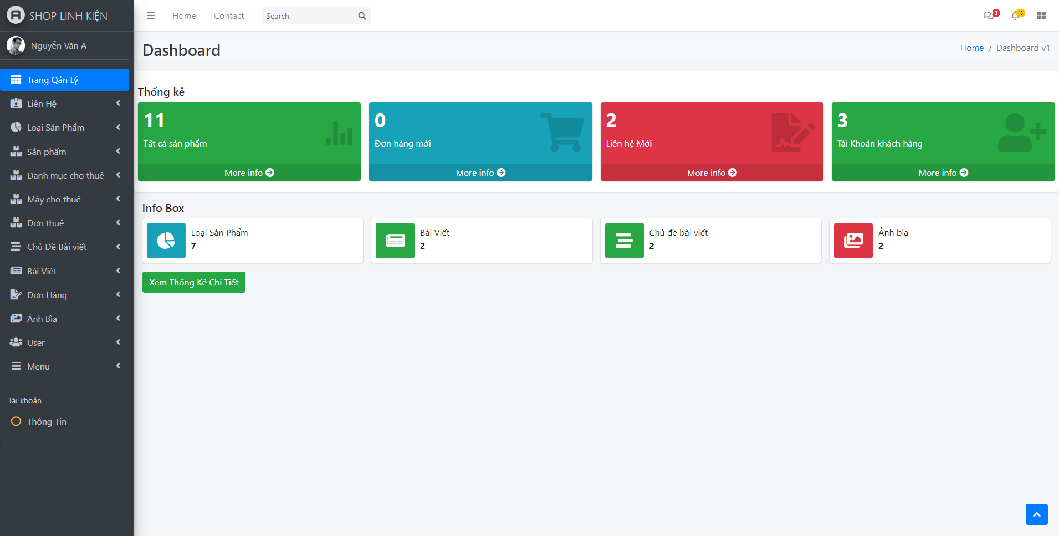

# **Coding Convention**

We write code according to C# coding conventions. everything is written according to microsoft's code conventions: https://docs.microsoft.com/en-us/dotnet/csharp/fundamentals/coding-style/coding-conventions.

# **9. User Guide**

Step1: Download code project.

Step2: Unzip the zip/rar file. Open the file "ShoplinhKien.sln" with Visual Studio.

Step3: Running database with file script.sql by Microsoft SQL Server Management Studio.

Step4: Open class Web.config find <connectionStrings></connectionStrings> and replace “data source= ” with your hostname.

Step5: Go to View -> Server Explorer -> Data Connections -> right-click "ChuoiKn(ShopLinhKien)" and select Refresh.

Step6:.Build Solution and run the program.

# **Appendix**